User Documentation

Getting Started
Lightswitch is a developer environment which allows the user to Define and Create data in table structures which can then be viewed from an application delivered via Silverlight to a browser or desktop client.

Installation
There are 3 parts to the install.
- Sql Server Express 2008 R2 with Advanced Services. The Details for this are in the separate Sql Server installation Guide.
- Data Migration.
- Silverlight Package Install (Lightswitch)
You will need to install Sql Server Express 2008 R2 with Advanced Services on the computer hosting the application. The Migration tool will create the database in Sql Server along with setting up the user permissions for the database.
After that step is completed, you will need to install the application package into IIS on the same “Server” computer. This will install the application to be hosted by IIS and therefore all PC’s in the office network will be able to browse using IE or another compatible Silver
The specific steps for an XP install of the IIS application follows.
- Enable/Install IIS on your XP “Server” Machine. Add/Remove Windows Components. Ensure that Internt Information Services (IIS) is checked and click Ok.
- Unzip the application files into the C:\inetpub directory. This should leave you with a folder called Contact Manager – PPT in that directory. This folder should contain the following files and folders:
  - Bin
  - Web
  - ClientAccessPolicy.xml
  - Default.htm
  - Silverlight.js
  - Web.config
- Ensure that Simple File Sharing is turned off in Tools | Folder Options | View in windows explorer.
- The Web.config file is the only file in the installation/application that you will need to modify in order to host the Contact List application on the machine.
  - Open Web.confif in notepad or a another raw text file editor (not Word or Wordpad).
  - Look for the following text: <add name="PPT_A1Data" connectionString="Data Source=.\sqlexpress;Initial Catalog=PPT;Integrated Security=True" />
  - This represents the database connection for the application. In the Sql Server installation steps from Liam, you specified the Sql Server Service to run as a local user with Administrative rights to the machine. This web application will run under the same user. We will need to set this up now.
  - Go to Start | Run | inetmgr to spin up IIS management and ensure the Local Path of the Default Website is pointing to the Local Path shown below (where we extracted the Application Files)
  - 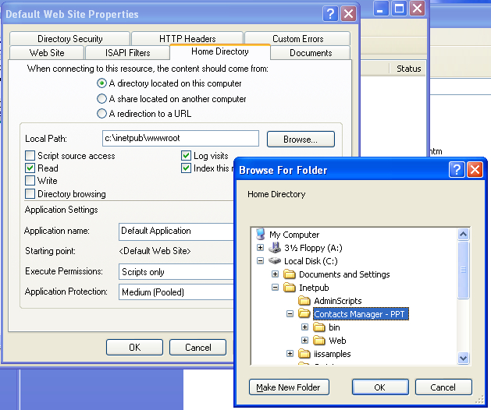
- Open The Web Browser Whilst on the machine and navigate to http://localhost in the address bar. The Browser should display a prompt similar to the screenshot below to install Silverlight on your machine, if it is not already installed.
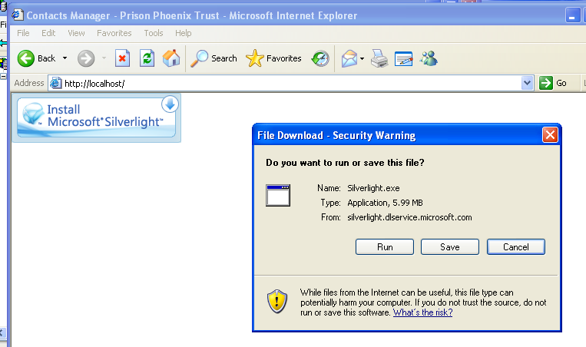

- If not already installed, download and install .NET 4.0 Framework (Full, not Client Profile).
- Run the following at the command prompt (start | run | cmd): C:\WINDOWS\Microsoft.NET\Framework\v4.0.30319\aspnet_regiis –I –c . Your framework version may be slightly different but you get the idea! This will install ASP.NET into IIS and the necessary security users on the machine.
- Open the security dialog for the folder we installed the applcation in. The Screenshot of the path and dialog is below:
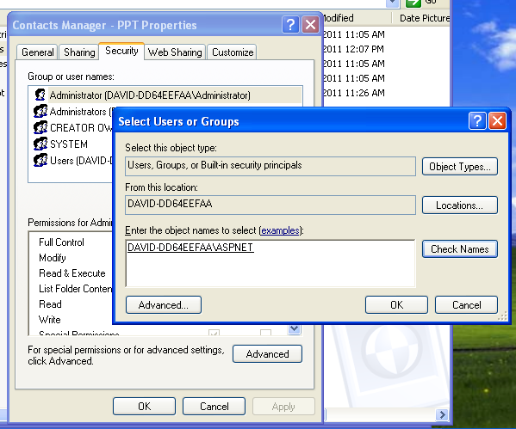

- Type ASPNET into the text entry above and press “Check Names”. This should then populate the fully qualified name of your machine in front of the user name.
- Click OK.
- Give that user modify rights to the folder.
- Repeat this for the user beginning “IUSR_” on your computer as well.
- Click OK. These steps are to ensure that the users which the application runs under has sufficient privileges to it’s own data.
Once this setup is completed on the “Server” XP machine, all computers on the same network will be able to access the Contacts application via the IP or hostname of the server machine. E.g. http://XP-MCHINE01/

Tips Section
Ways (not) to add a Contact…

